Project: Net Guard– Threat Detection Bot

1. Introduction
The Threat Detection Bot is a Python-based module designed to monitor network traffic and detect suspicious activities such as port scanning and abnormal bandwidth usage. This document describes the technical architecture and system flow used in this module.

2. System Overview
The system captures live network packets, analyzes them using detection logic, and identifies anomalies. When suspicious activity is detected, alerts are generated and stored in the database.

3. Technology Stack
- Python – Core implementation
- Scapy – Packet capturing and analysis
- Flask – API layer
- PostgreSQL – Log storage

4. System Architecture
The Net Guard Threat Detection Bot follows a simple modular architecture. The system is divided into different components, where each component performs a specific task like capturing data, analyzing it, generating alerts, and storing information.

🔹 Components

- Packet Sniffer (Scapy)
Captures live network packets and extracts basic details like IP address and packet size.
- Detection Engine
Analyzes the captured data and detects suspicious activities such as port scanning and high bandwidth usage.
- Alert System
Generates alerts when suspicious activity is detected.
- API Layer (Flask)
Provides endpoints to access alerts and logs.
- Database (PostgreSQL)
Stores traffic data and alerts for future use.

🔹 Working Flow
- Packet Sniffer captures network data
- Data is sent to Detection Engine
- Detection Engine checks for threats
- If threat found → Alert is generated
- Data is stored in Database
- API provides access to alerts and logs

5. Component Diagram

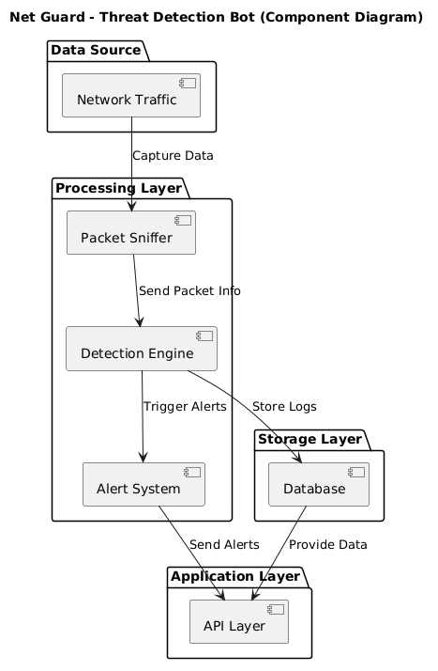

Code for component diagram
@startuml
title Net Guard - Threat Detection Bot (Component Diagram)
package "Data Source" {
[Network Traffic]
}

package "Processing Layer" {
[Packet Sniffer]
[Detection Engine]
[Alert System]
}

package "Storage Layer" {
[Database]
}

package "Application Layer" {
[API Layer]
}

[Network Traffic] --> [Packet Sniffer] : Capture Data
[Packet Sniffer] --> [Detection Engine] : Send Packet Info

[Detection Engine] --> [Alert System] : Trigger Alerts
[Detection Engine] --> [Database] : Store Logs

[Alert System] --> [API Layer] : Send Alerts
[Database] --> [API Layer] : Provide Data

@enduml

6. Detailed Component Working

- Packet Sniffer (Scapy)
- Captures network packets in real-time
- Extracts details like source IP, destination IP, and packet size
- Continuously monitors traffic
- Sends captured data to the Detection Engine
- Detection Engine
- Receives packet data from the sniffer
- Analyzes traffic patterns
- Detects:
- Port scanning (repeated requests from same IP)
- High bandwidth usage (sudden traffic spike)
- Marks traffic as normal or suspicious
- Sends suspicious data to Alert System
- Stores required data in Database
- Alert System
- Generates alerts for suspicious activity
- Classifies alerts based on type and severity
- Sends alert details to API Layer
- API Layer (Flask)
- Provides endpoints like /alerts and /logs
- Handles requests from users or applications
- Fetches data from Database
- Sends responses back to users
- Database (PostgreSQL)
- Stores traffic logs and alerts
- Maintains details like IP address, activity type, timestamp, and status
- Keeps data for future analysis and reporting

7. Data Flow

The system captures network packets and sends them to the detection engine for analysis. If any suspicious activity is detected, an alert is generated and stored in the database. The API layer provides access to alerts and logs.
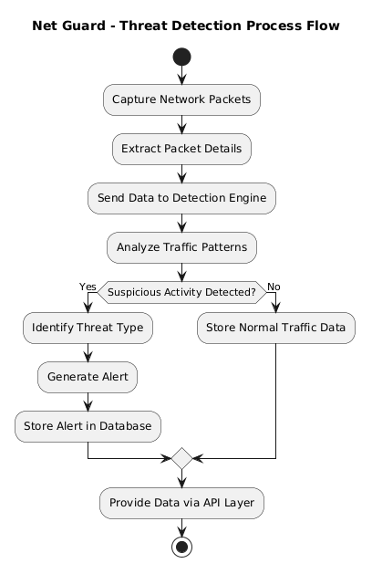

Code for flowchart diagram

@startuml
title Net Guard - Threat Detection Process Flow

start

:Capture Network Packets;
:Extract Packet Details;

:Send Data to Detection Engine;
:Analyze Traffic Patterns;

if (Suspicious Activity Detected?) then (Yes)
:Identify Threat Type;
:Generate Alert;
:Store Alert in Database;
else (No)
:Store Normal Traffic Data;
endif

:Provide Data via API Layer;

stop
@enduml

8. Database Schema

The database stores network traffic data, detected threats, and alerts in a structured manner.
Table 1: Threat-logs

Field | Type
id | INT
ip_address | VARCHAR
activity | VARCHAR
timestamp | TIMESTAMP
status | VARCHAR

Table 2: Alerts

Field | Type
Alert_id | INT
Ip_address | VARCHAR
Alert_type | VARCHAR
timestamp | TIMESTAMP
severity | VARCHAR

Table 3: Traffic Data

Field | Type
id | INT
Source_ip | VARCHAR
Destination _ip | VARCHAR
Packet_size | INT
Timestamp | TIMESTAMP

Traffic_Data stores raw packet information, Threat_Logs store detected suspicious activities, and Alerts store final alert notifications.

ER Diagram

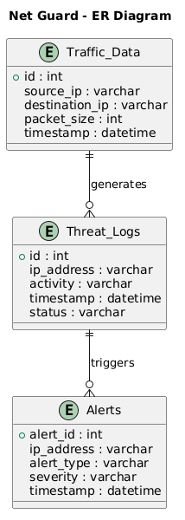

Code for ER diagram

@startuml
title Net Guard - ER Diagram

entity "Traffic_Data" {
+id : int
source_ip : varchar
destination_ip : varchar
packet_size : int
timestamp : datetime
}
entity "Threat_Logs" {
+id : int
ip_address : varchar
activity : varchar
timestamp : datetime
status : varchar
}

entity "Alerts" {
+alert_id : int
ip_address : varchar
alert_type : varchar
severity : varchar
timestamp : datetime
}

Traffic_Data ||--o{ Threat_Logs : generates
Threat_Logs ||--o{ Alerts : triggers

@enduml

9. Conclusion
The Net Guard Threat Detection Bot monitors network traffic and detects suspicious activities in real-time. It captures data, identifies threats, generates alerts, and stores information for easy access.

10.Annexure

- Glossary

• Packet Sniffer – A component that captures network packets in real-time using Scapy
• Detection Engine – Core logic that analyzes traffic and detects suspicious patterns
• Port Scanning – Multiple connection requests sent to different ports of a system
• Bandwidth Usage – Amount of data transferred over the network in a given time
• API Layer – Interface (Flask) used to expose system data via endpoints
• Logs – Stored records of detected activities and network events

- Assumptions

• The system runs in an environment with continuous network access
• Required libraries (Scapy, Flask, PostgreSQL) are properly installed
• The system has adequate CPU and memory for real-time packet processing
• Users have necessary permissions to capture network packets

- Constraints

•High network traffic may increase processing time
• Detection depends on predefined rules, may not catch all advanced attacks
• Packet capturing may require elevated (admin/root) permissions
• System performance depends on hardware and network conditions

- Future Enhancements

• Integration of Machine Learning models for advanced threat detection
• Development of a web-based dashboard for visualization
• Real-time alert notifications via Email/SMS
• Support for detecting advanced threats (DDoS, intrusion attempts)
- References

• Scapy Documentation
• Flask Official Documentation
• PostgreSQL Documentation
• Network Security and Packet Analysis Concepts

